| **永豐金 2890** | | | **epochs** | | **hidden size** | | **訓練集** | **測試集** | **end LOSS** | |
| --- | --- | --- | --- | --- | --- | --- | --- | --- | --- | --- |
|
| **2019/9/8**  **~**  **2022/8/16** | | | **500** | | **50** | | **16** | **4** | **0.00188305** | |
| **1000** | | **50** | | **16** | **4** | **0.00022901** | |
| **1500** | | **50** | | **16** | **4** | **0.00021301** | |
| **2000** | | **50** | | **16** | **4** | **0.00009703** | |

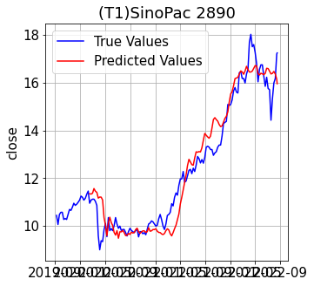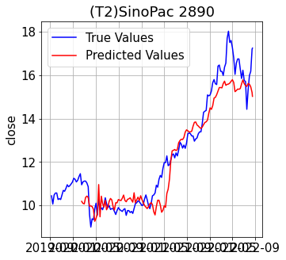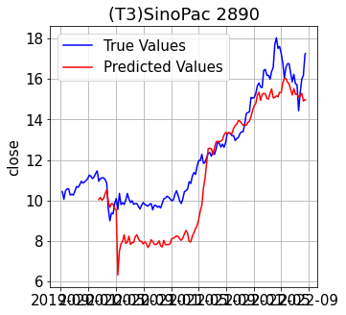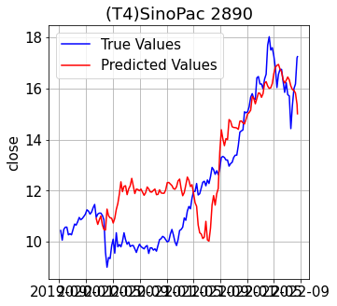

| **永豐金 2890** | | | **epochs** | | **hidden size** | | **訓練集** | **測試集** | **end LOSS** | |
| --- | --- | --- | --- | --- | --- | --- | --- | --- | --- | --- |
|
| **2019/9/8**  **~**  **2022/8/16** | | | **500** | | **10** | | **16** | **4** | **0.00474566** | |
| **500** | | **30** | | **16** | **4** | **0.00045390** | |
| **500** | | **80** | | **16** | **4** | **0.00077814** | |
| **500** | | **100** | | **16** | **4** | **0.00079808** | |

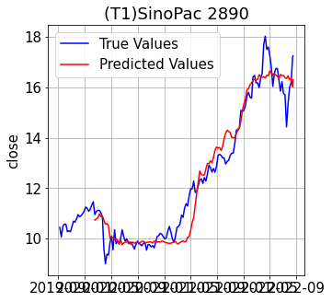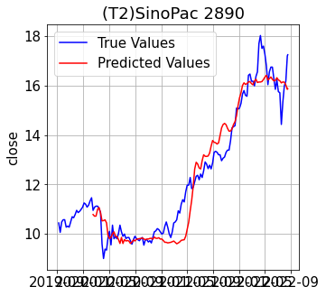

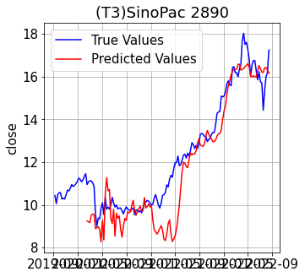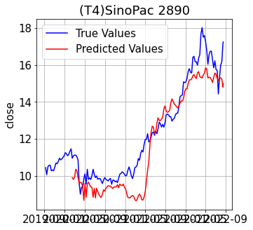

| **華南 2880** | | | **epochs** | | **hidden size** | | **訓練集** | **測試集** | **end LOSS** | |
| --- | --- | --- | --- | --- | --- | --- | --- | --- | --- | --- |
|
| **2019/9/8**  **-**  **2022/8/16** | | | **500** | | **50** | | **16** | **4** | **0.00033166** | |
| **1000** | | **50** | | **16** | **4** | **0.00009385** | |
| **1500** | | **50** | | **16** | **4** | **0.00002143** | |
| **2000** | | **50** | | **16** | **4** | **0.00009109** | |

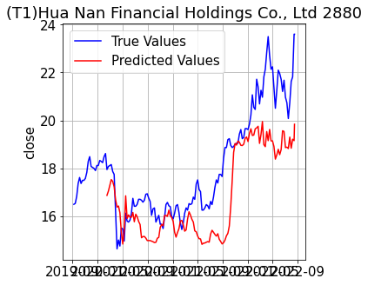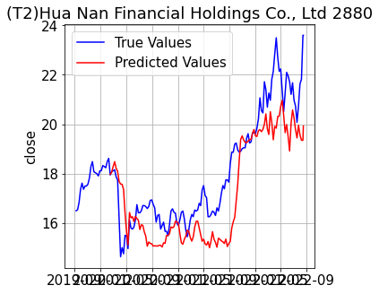

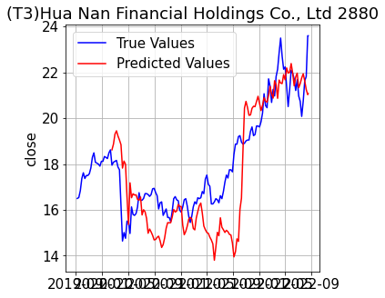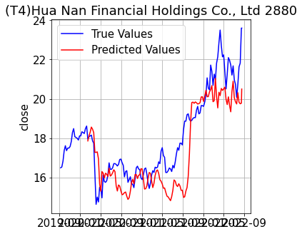

| **永豐金 2890** | | | **epochs** | | **hidden size** | | **訓練集** | **測試集** | **end LOSS** | |  |
| --- | --- | --- | --- | --- | --- | --- | --- | --- | --- | --- | --- |
|
| **2019/9/8**  **~**  **2022/8/16** | | | **500** | | **100** | | **8** | **8** |  | | **測試** |
|  | |  | |  |  |  | |  |
|  | |  | |  |  |  | |  |
|  | |  | |  |  |  | |  |

